By clicking in “Mail”, I have access to my Inbox mail folder.
Then, I click in the “New Mail button”, which looks like a pencil.
A New Mail screen opens and I do as the following image:

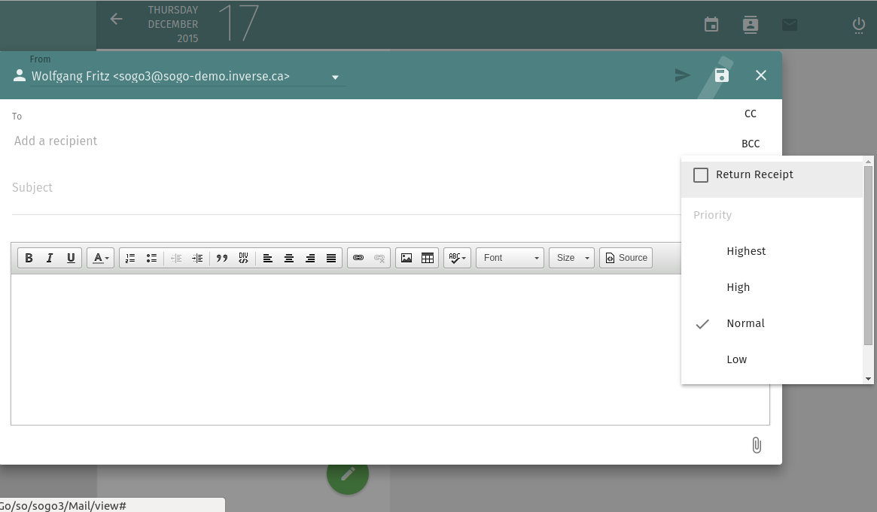

But, when I click in the checkbox “Return Receipt”, everything behind the New Mail screen is gone. As you can see in the next print screen image.



